Asha mohamed Noor
Software engineering

Task 1
Flutter and dart setup
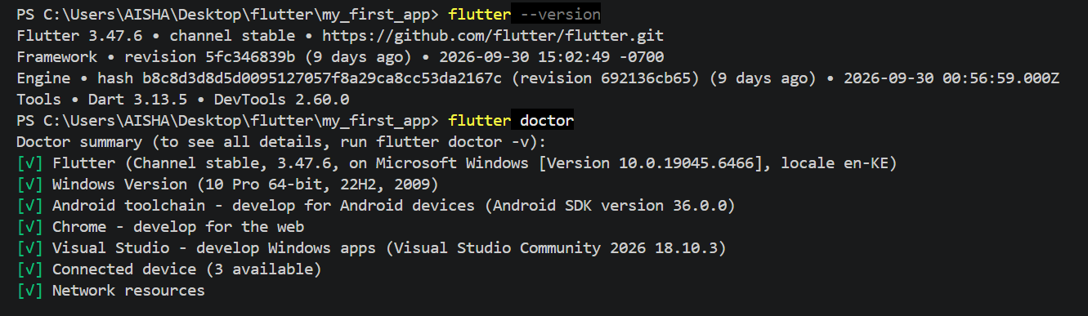
2.
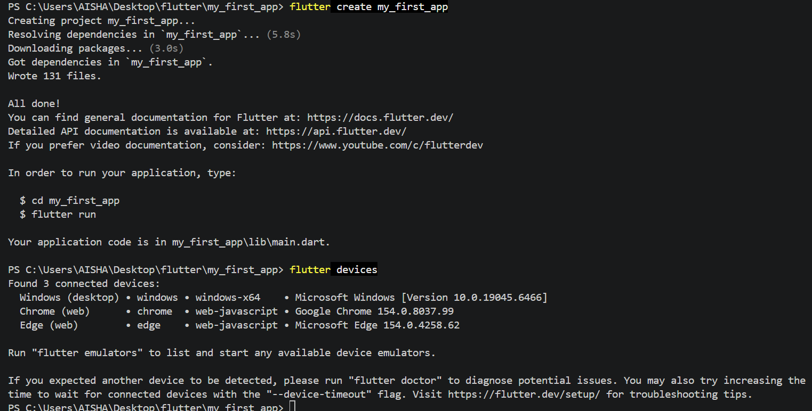
3.Hot Reload applies code changes while preserving the current state, whereas Hot Restart restarts the application and resets its in-memory state. Developers should use Hot Reload for quick UI updates and Hot Restart when a complete application restart is necessary.

Task2 MYSQL DATABASE MANAGEMENT

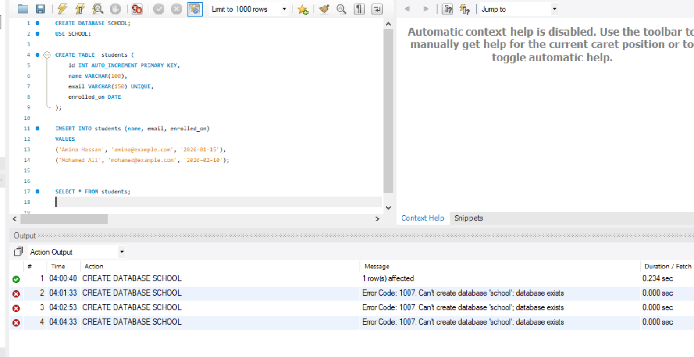
TASK3 Python Environment & Dependency Isolation
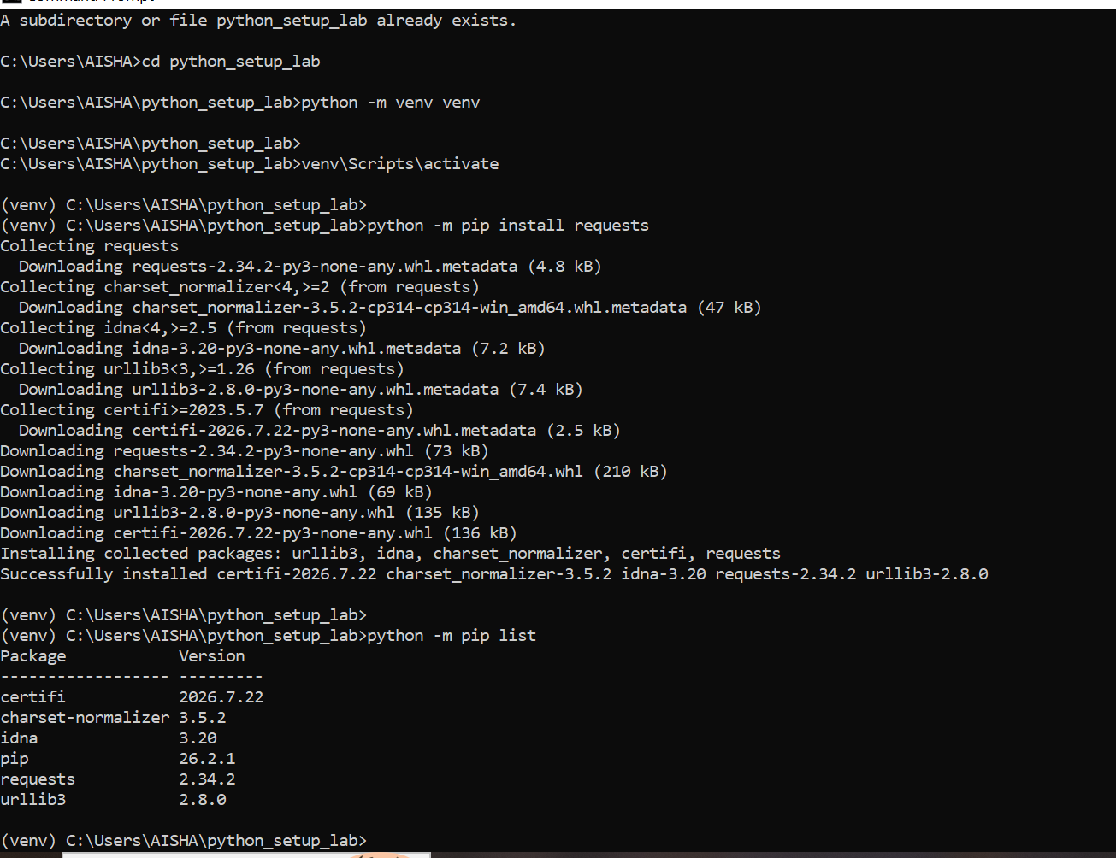

TASK4 Vs Code Workspace configuration
